Click on Tools, then Click News Tab and then ADD at the top.
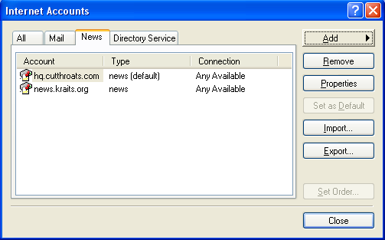

Then complete the following:
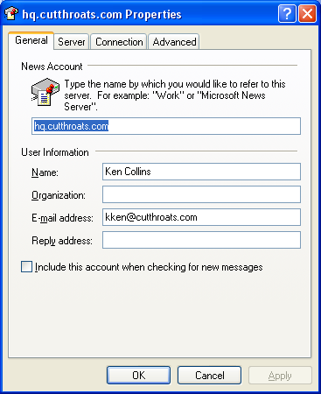
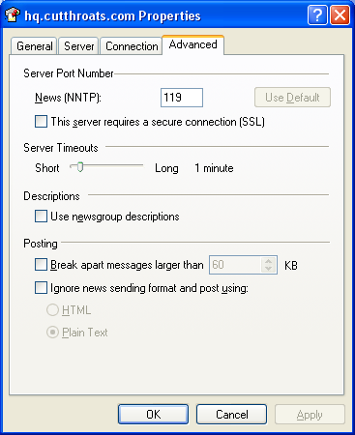
Click on the Server Tab like so:
(I usually don’t enter my password here so I wont forget it.)
On the Advanced Tab Port 119

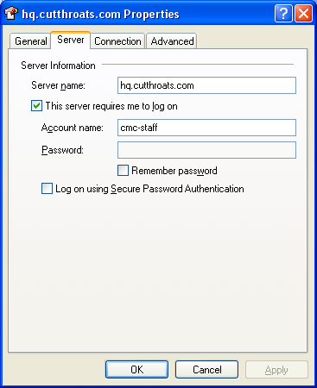
Then the trick it to download all messages, Subscribe to all the Newsgroups listed.
These are the best ones.

